

Project Name: ICC T20 World Cup

Course Name: Database Systems

Course: CSE302

Section: 03

Submission Date: 16-09-22

**Submitted To:**

Md Al-Imran

Lecturer

Department of Computer Science & Engineering

**Submitted By:**

Navid zaman 2020-2-60-044

Md Tahsin 2020-2-60-112

Najnin Sultana Nishu 2020-1-60-152

Sumaiya Sanjin 2019-3-60-105

DM Rafiun Bin Masud 2019-3-60-137

**Project URL:** [**https://apex.oracle.com/pls/apex/r/navidproject22/t20-world-cup-2022/login?session=104015241237392**](https://apex.oracle.com/pls/apex/r/navidproject22/t20-world-cup-2022/login?session=104015241237392)

**ICC T20 World Cup**

**Project Description:**

Our project is about Database of ‘ ICC Men's T20 World Cup’. There will be tables and other features. Here we can find match schedule of the tournament, vanues. Moreover, it will show players details such as career with player images. Its not only about the players and vanues informations. It will also show the team management, squad and tournaments records. Here, we can find a full of informations and queuries.

**Objective:**

Here we have focused on the informations and other details about ICC T20 World Cup. It’s a computer or web-based application that manages all information whatever the user needs.

**E-R Diagram:**

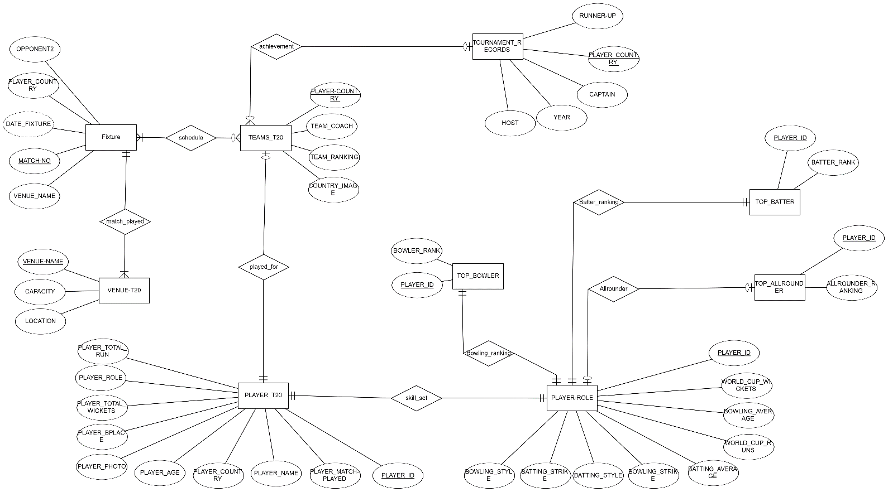

**Relational schema:**

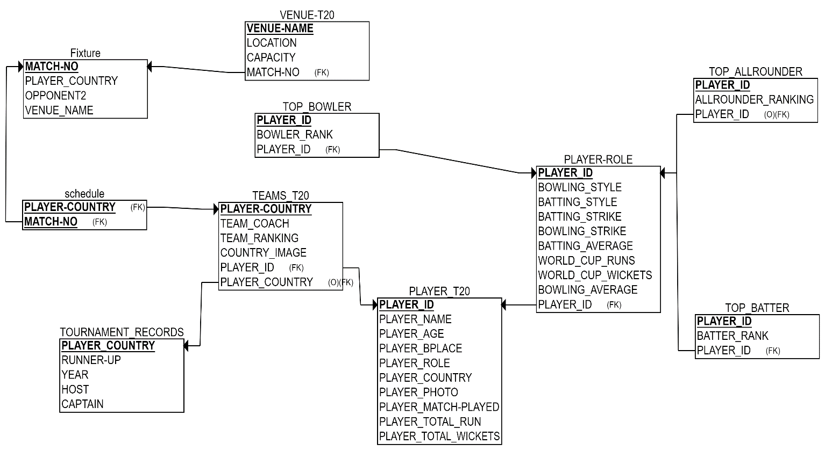

**Key Features:**

WE have used various features to make our project and these are-

* SQL Query
* Master Table
* Natural join
* Drop down box
* trigger
* picture added
* validation Form
* Custom Authorization -

Normal user cannot update the table because of authorization. For an example, we can see the image below an user tried to add player however it will deny the action.

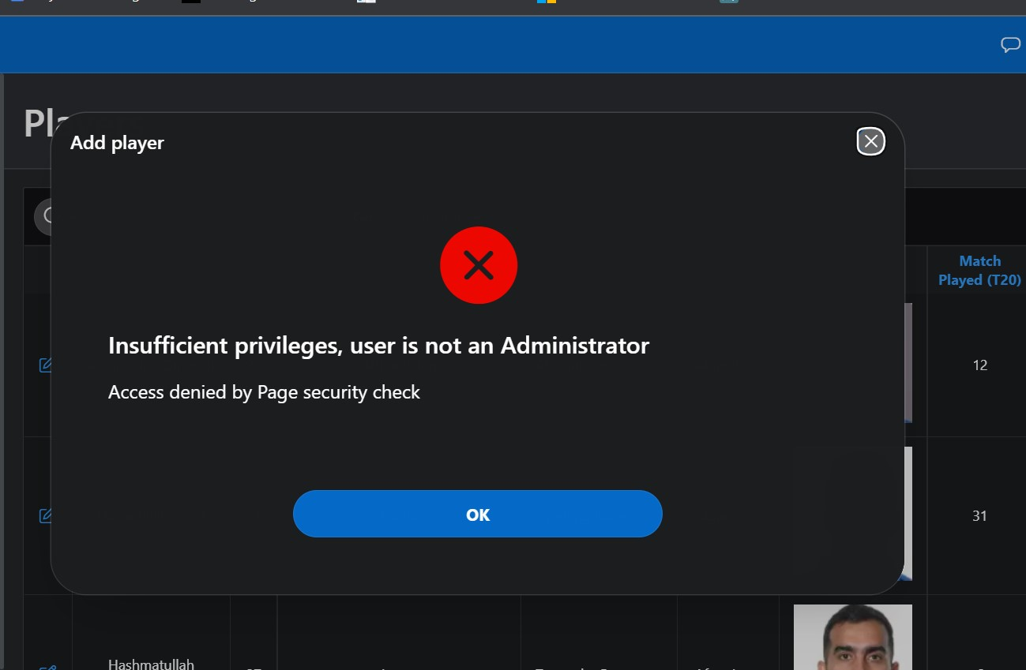

**Login page**: Here is the login page and the URL -

[**https://apex.oracle.com/pls/apex/r/navidproject22/t20-world-cup-2022/login?session=104015241237392**](https://apex.oracle.com/pls/apex/r/navidproject22/t20-world-cup-2022/login?session=104015241237392)

Where the admin id – **admin_t20** and password- **q1w2e3r4**

And the user id – **test_t20** and password- **q1w2e3r4**

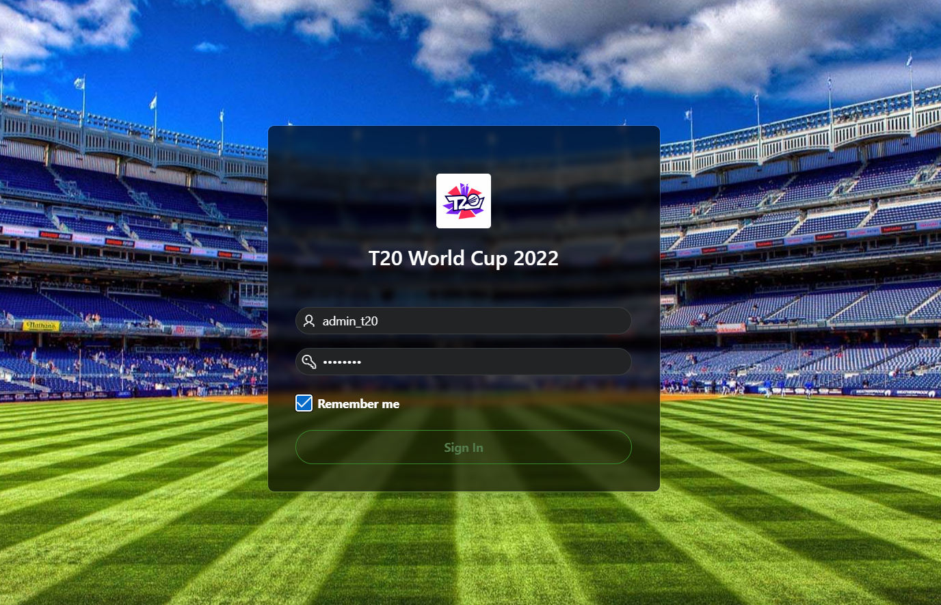

**Tables:**

**1.Home page**: In this front page there are button. Which will help to go other pagers to get information of the tournament.

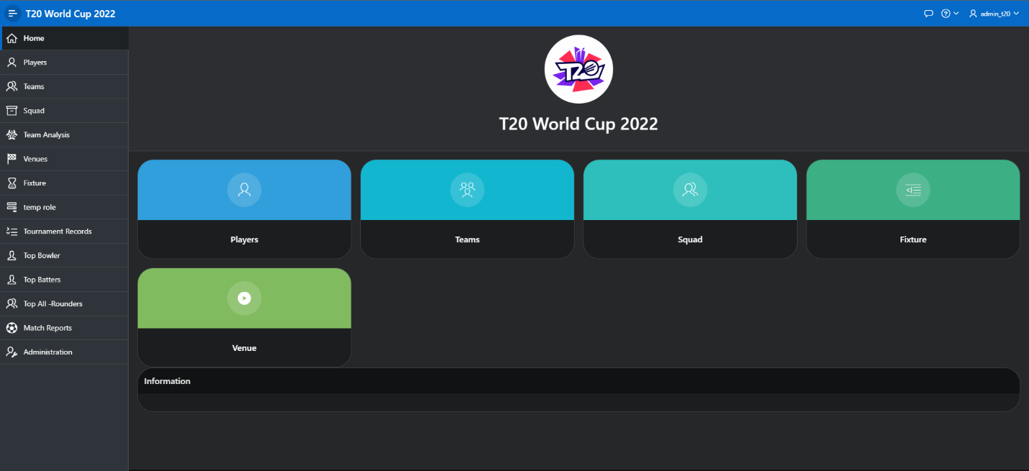

**2.Player table:** This table will show all the players information. It has search feature where user can search by player name. Below in the pictures we can see **Rohit sharma’s information**.

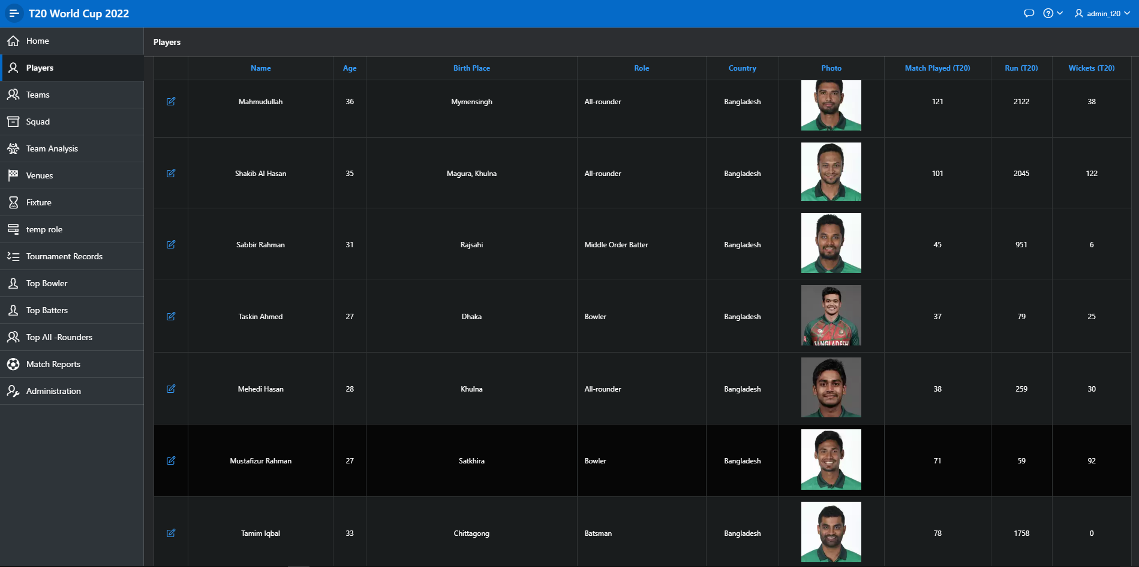

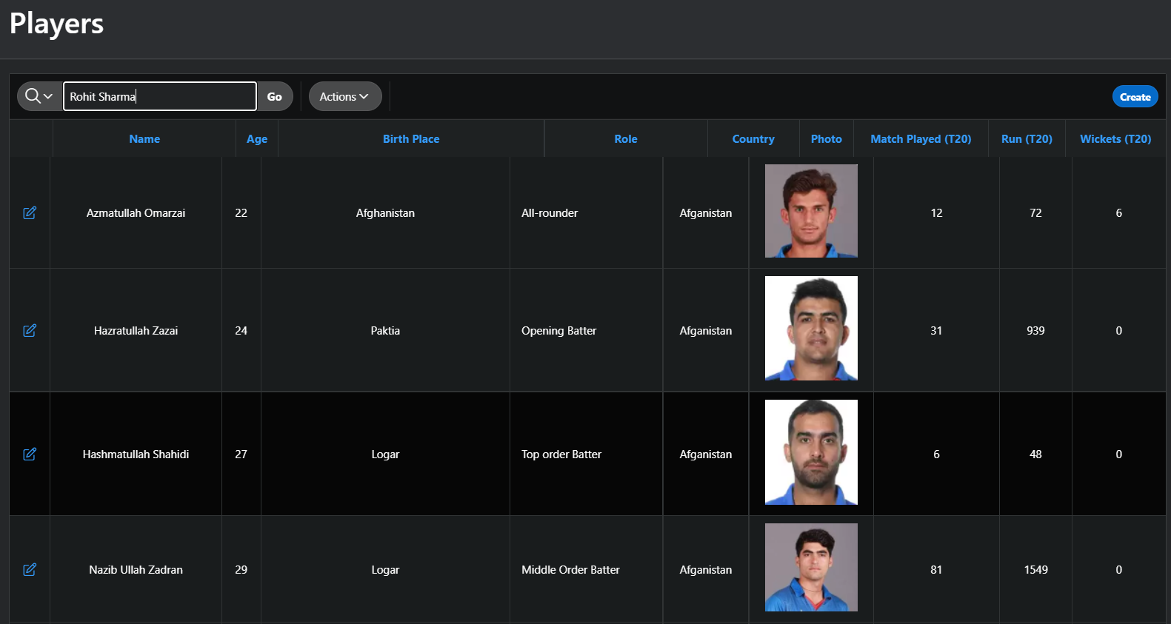

**3.Teams**: In this table there are team. There are features that will help a user to know the exect information whatever they want.

**4.Squad:** This table will help a user to find squad list where all the list added alphabetical order. There is a feature and that is searching.

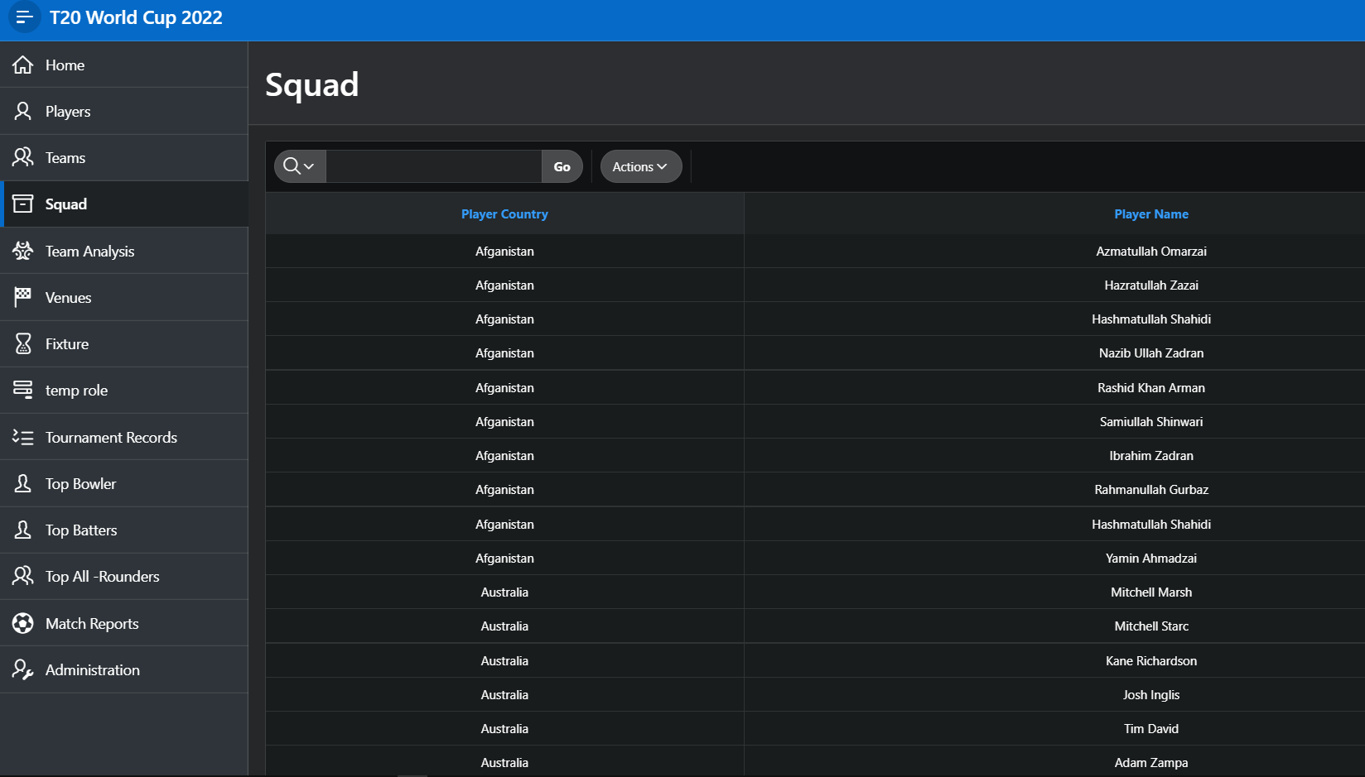

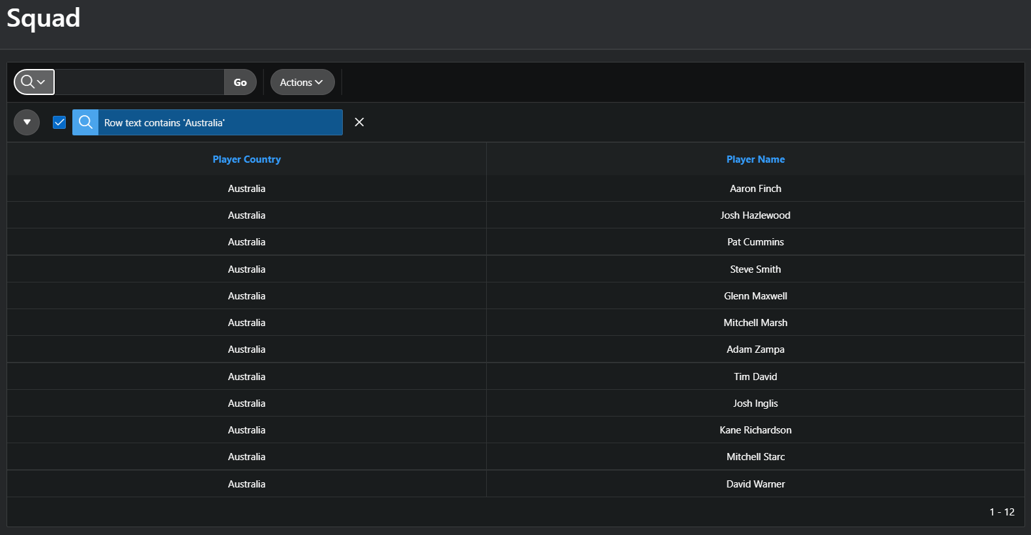

**5.Team Analysis:** This is the **Master detail** Table where we can see two tables. Here, A list with county, ranking and team coach. The main feature is when user selects county it will show full team player information. We can see in the images below a user have selected Bangladesh and it show the list of the team.

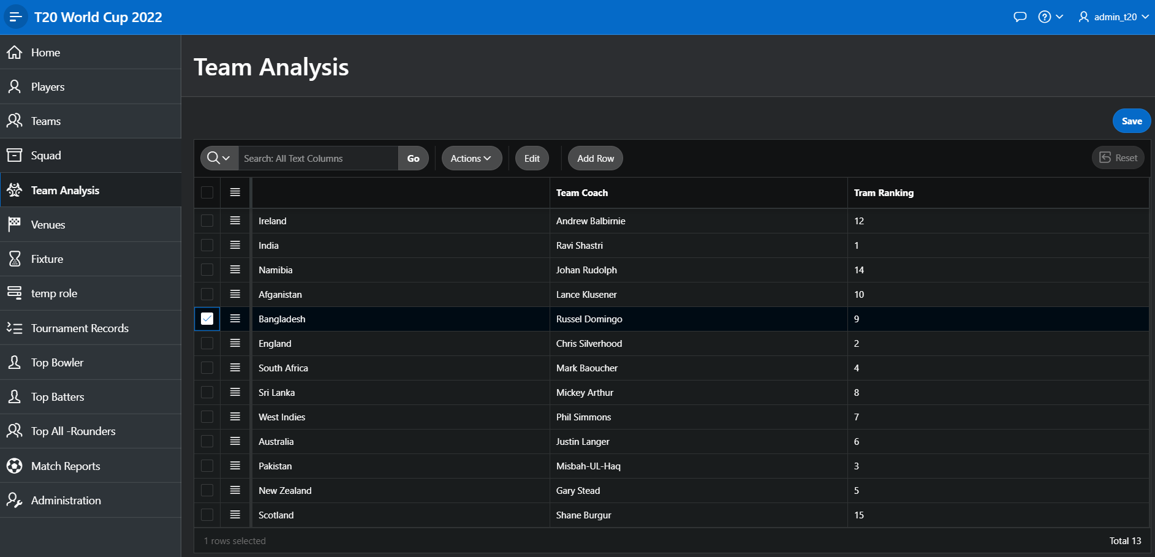

**6.Vanue**: In this vanue table a user can see vanue name with location and capacity.

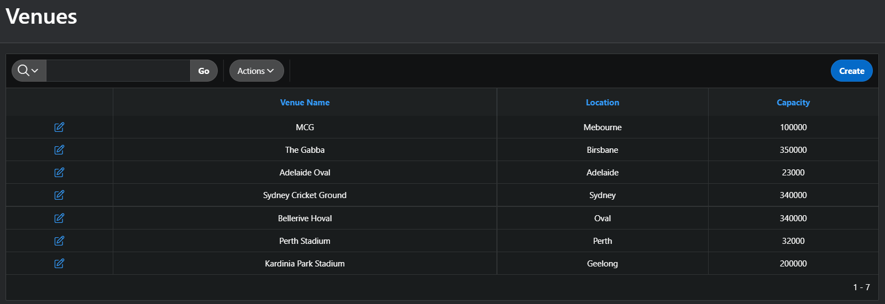

**7.Fixtures:**All the match fixtures with date,place, team name have been depected.

**8.Tournament Records:**

This table will show all the winners of past tournaments where we can see winners,runner up, host,captains name.

**9.Top Bowlers:**

Here in this table it will show top bowlers list. Where we can search by name of player.

**10.Top Batters:** Here in this table it will show top batsman’s list. Where we can search by name of player.

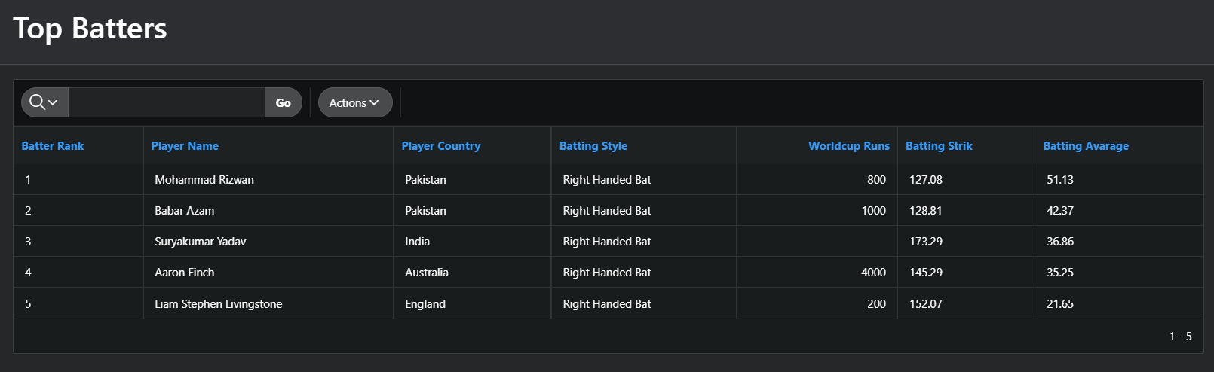

**11.Top All-Rounders:** Here in this table it will show top All-Rounders list. Where we can search by name of player.

**12.Match reports:** After matches the result will be updated in **Match Repost** table.

**Conclusion:**

Here we use Oracle APEX to build an application “Icc T20 World cup 2022”. Here we learn how to build an application and add different type of page to make useful and learn how to authorise user and maintain database. Here we face some problem like image resize, use html and CSS, “space quota exceeded for tablespace” problem and this project consumes more time during data input. Because of this is a team project so, when we face any problem, we discuss and solve it quickly and there is the main fun to work with group project.